Project Design Phase-II
Technology Stack (Architecture & Stack)

Date | 28 September 2026
Team ID | SWTID-2026-2169
Project Name | Import Data Using Transform Map
Maximum Marks | 4 Marks
Technical Architecture:
The deliverable shall include the architecture diagram of the data import process, showing the flow from the data source (Excel/CSV file) to the Import Set table, through the Transform Map, and into the Service Now target table, as shown below, along with the information as per Table 1 and Table 2.
Guidelines:

Include all the processes (As an application logic / Technology Block)
Provide infrastructural demarcation (Local / Cloud) Indicate external interfaces (third party API’s etc.) Indicate Data Storage components / services
Indicate interface to machine learning models (if applicable)

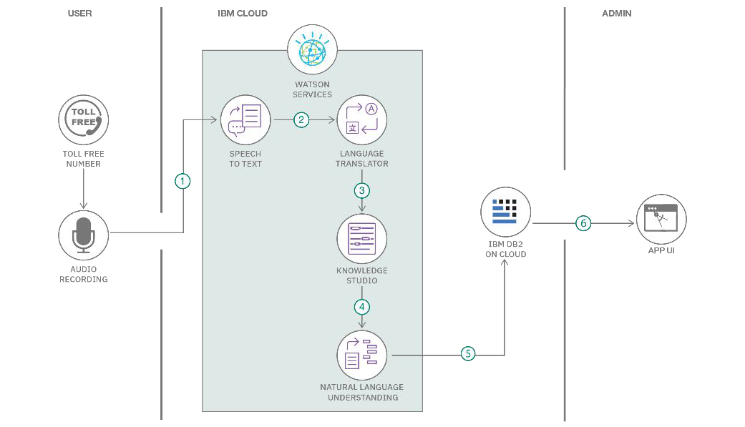

Table-1 : Components & Technologies:
S. No | Component | Description | Technology
1. | User Interface | How user interacts with application e.g. Web UI, Mobile App, Chat bot etc. | HTML, CSS, JavaScript / Angular Js / React Js etc.
2. | Application Logic-1 | Logic for a process in the application | Java / Python
3. | Application Logic-2 | Logic for a process in the application | IBM Watson STT service
4. | Application Logic-3 | Logic for a process in the application | IBM Watson Assistant
5. | Database | Data Type, Configurations etc. | MySQL, NoSQL, etc.
6. | Cloud Database | Database Service on Cloud | IBM DB2, IBM Cloudant etc.
7. | File Storage | File storage requirements | IBM Block Storage or Other Storage Service or Local Filesystem
8. | External API-1 | Purpose of External API used in the application | IBM Weather API, etc.
9. | External API-2 | Purpose of External API used in the application | Aadhar API, etc.
10. | Machine Learning Model | Purpose of Machine Learning Model | Object Recognition Model, etc.
11. | Infrastructure (Server / Cloud) | Application Deployment on Local System / Cloud Local Server Configuration:  Cloud Server Configuration : | Local, Cloud Foundry, Kubernetes, etc.

Table-2: Application Characteristics:
S. No | Characteristics | Description | Technology
1. | Open-Source Frameworks | List the open-source frameworks used | Technology of Open source framework
2. | Security Implementations | List all the security / access controls implemented, use of firewalls etc. | e.g. SHA-256, Encryptions, IAM Controls, OWASP etc.
3. | Scalable Architecture | Justify the scalability of architecture (3 – tier, Micro-services) | Technology used
4. | Availability | Justify the availability of application (e.g. use of load balancers, distributed servers etc.) | Technology used
5. | Performance | Design consideration for the performance of the application (number of requests per sec, use of Cache, use of CDN’s) etc. | Technology used

